Backtest Summary Report

Executive Summary
Portfolio (annualised): Return=14.33%, Volatility=18.53%, Sharpe=0.649
Key takeaways:
- Best method (by Sharpe): MSR (Sharpe=1.001, Return=23.15%, Vol=20.81%)
- Worst method (by Sharpe): GMV (Sharpe=0.315, Return=6.62%, Vol=13.69%)
- Top 3 tickers by CAGR: MSFT (0.27), AAPL (0.24), ATT.L (0.19)
- Worst drawdown: -29.92% on 2020-03-23

Charts
Wealth Index Comparison
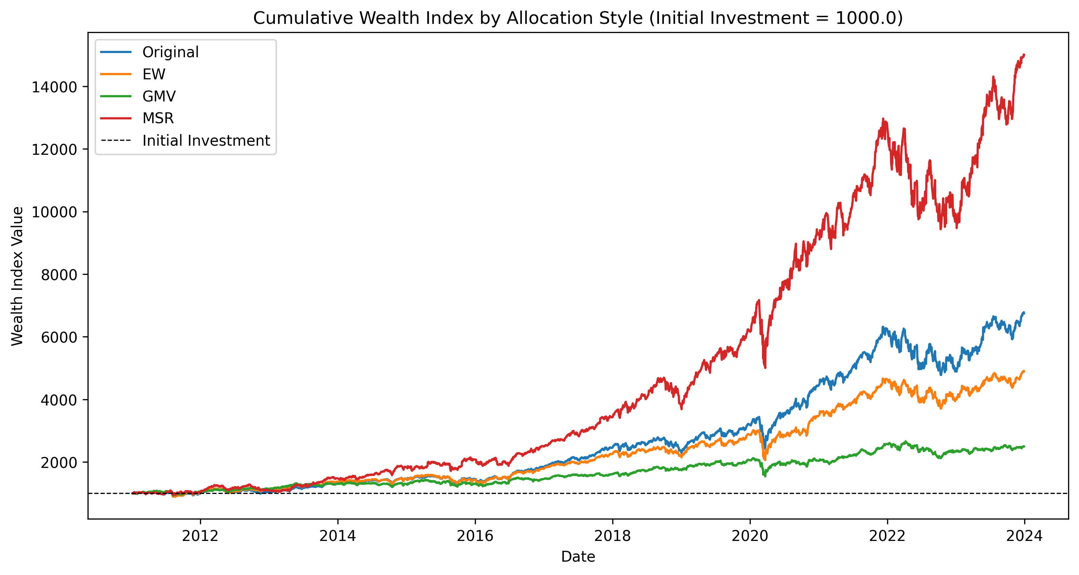
Efficient Frontier
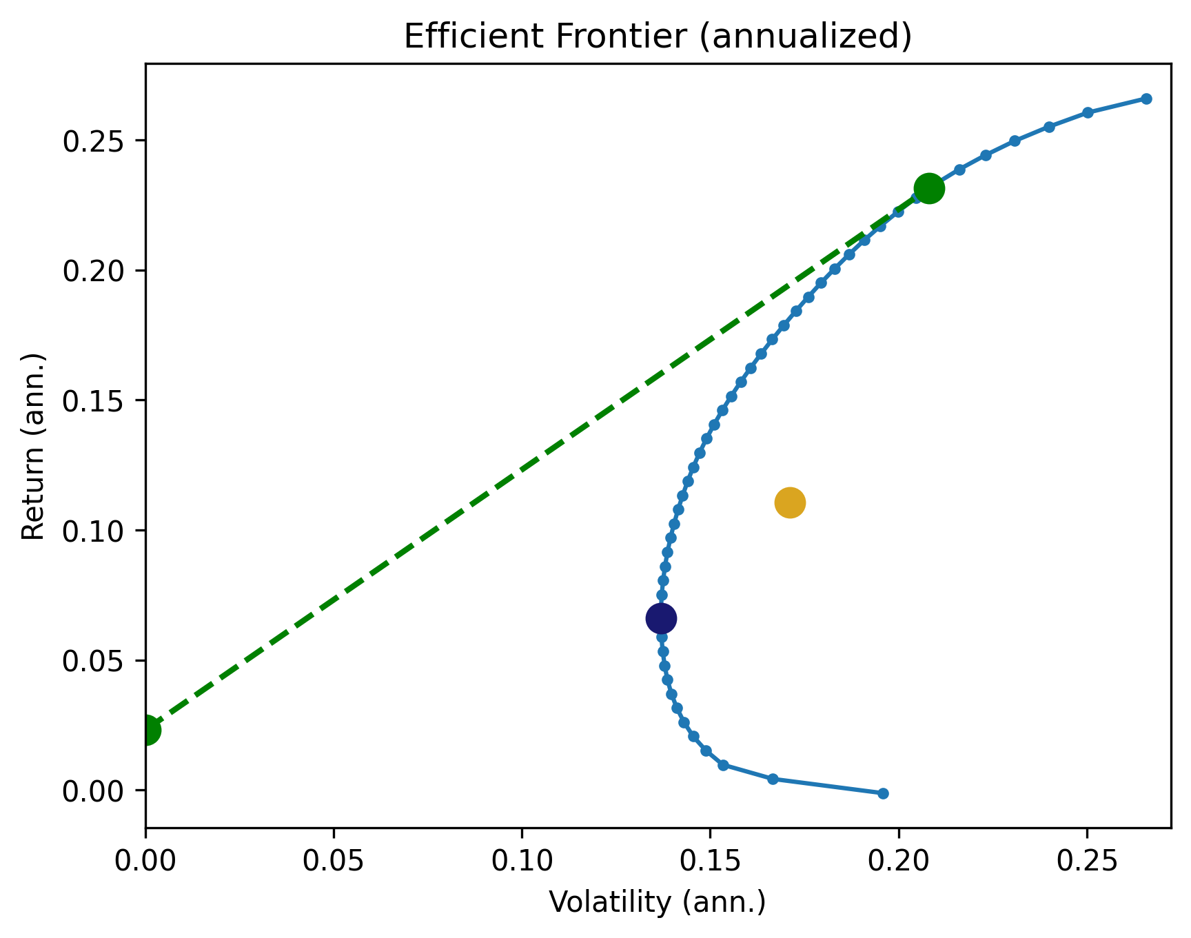

Portfolio Results
index | Portfolio Returns% | Portfolio Volatility% | Portfolio Sharpe Ratio
0.0000 | 14.3338 | 18.5333 | 0.6489

Methods Summary
index | Method | Return (ann.%) | Vol (ann.%) | Sharpe
0.0000 | Original | 14.3338 | 18.5333 | 0.6489
1.0000 | EW | 11.0526 | 17.1055 | 0.5112
2.0000 | GMV | 6.6165 | 13.6877 | 0.3148
3.0000 | MSR | 23.1470 | 20.8148 | 1.0012

Top Weights (Top 5 per Method)
index | Method | Top1 | Top2 | Top3 | Top4 | Top5
0 | Original | MSFT: 13.82% | ATT.L: 12.15% | MRVL: 11.77% | AAPL: 9.80% | ISF.L: 8.98%
1 | EW | ISF.L: 5.88% | ADM.L: 5.88% | TW.L: 5.88% | ALB: 5.88% | TXN: 5.88%
2 | GMV | ISF.L: 24.86% | GSK.L: 24.21% | PFE: 14.59% | BRK-B: 13.10% | ADM.L: 8.43%
3 | MSR | MSFT: 47.11% | ATT.L: 23.28% | AAPL: 18.31% | CACI: 11.29% | ISF.L: 0.00%

Top 15 CAGR Tickers
index | Ticker | CAGR
11.0000 | MSFT | 0.2659
0.0000 | AAPL | 0.2407
3.0000 | ATT.L | 0.1854
7.0000 | GOOGL | 0.1773
6.0000 | CACI | 0.1677
15.0000 | TXN | 0.1656
5.0000 | BRK-B | 0.1221
10.0000 | MRVL | 0.1111
14.0000 | TW.L | 0.1101
12.0000 | PFE | 0.1003
2.0000 | ALB | 0.0972
1.0000 | ADM.L | 0.0475
16.0000 | VOW3.DE | 0.0358
13.0000 | SHEL.L | 0.0214
4.0000 | BHP.L | 0.0166

Drawdown Table (Last 15 rows)
index | Date | Wealth | Peaks | Drawdown
0.0000 | 2020-03-23 | 2411.0010 | 3440.1205 | -0.2992
1.0000 | 2020-03-16 | 2468.0446 | 3440.1205 | -0.2826
2.0000 | 2020-03-20 | 2470.9904 | 3440.1205 | -0.2817
3.0000 | 2020-03-18 | 2477.7971 | 3440.1205 | -0.2797
4.0000 | 2020-03-19 | 2506.7556 | 3440.1205 | -0.2713

